Nicholas Sessa

CS-210-R3200 Programming Languages 24EW3

2/22/2024

Project 3 - Corner Grocer

Design and Functionality

This implementation of the “Corner Grocer” requires a text file called “inventory.txt” be placed in the working directory of the project. When run, the application will display the following:

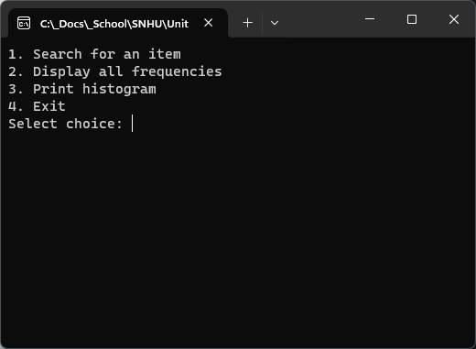

The user must enter a numeric value and then hit <ENTER>. Invalid input will be caught and the user will be shown the following:

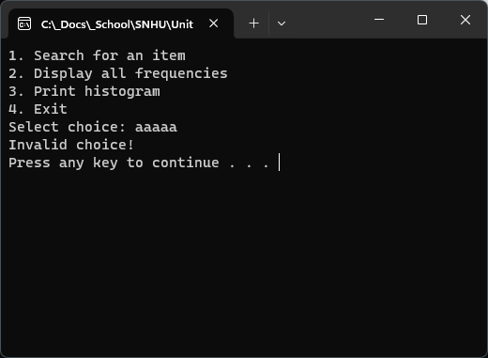

After “Pressing any key to continue…”, the user will be presented with the menu again. Integer values that are outside the range (1-4) will also be caught and a similar display will result. The screen will clear after every “Press any key to continue…”.

If the user selects option 1, he will be given a prompt to enter in the name of the item to be searched for.

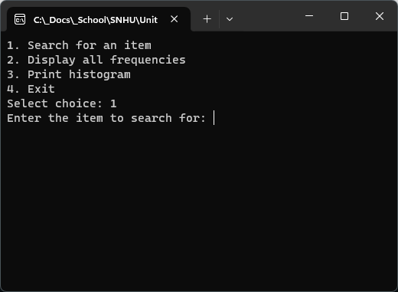

The input IS case sensitive, accordingly “Pears” is not the same as “pears” and therefore if “pears” is searched for, the results will be zero.

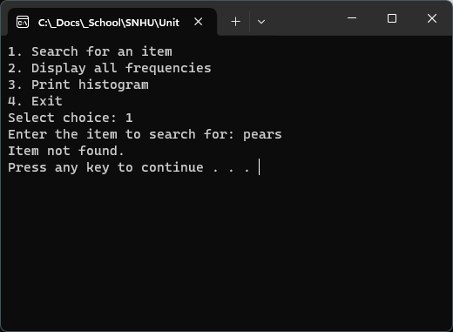

However, if the item is in the inventory, the following will be displayed:

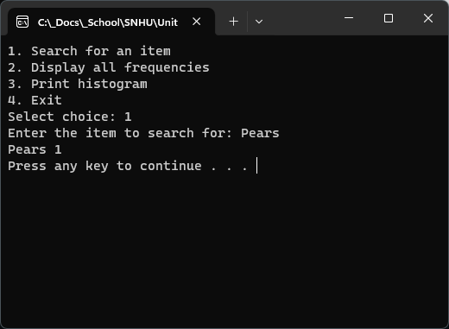

If the user selects option 2, the application will output to the screen all the items in the database and their quantities:

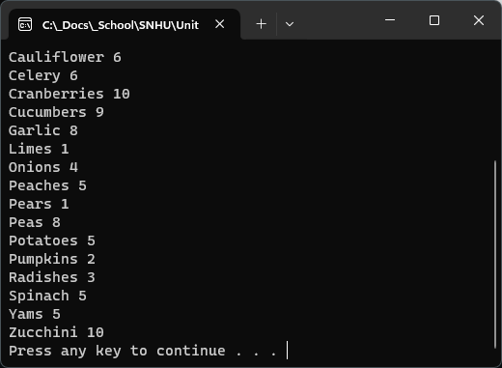

If the user selects option 3, a histogram of the same will be displayed:

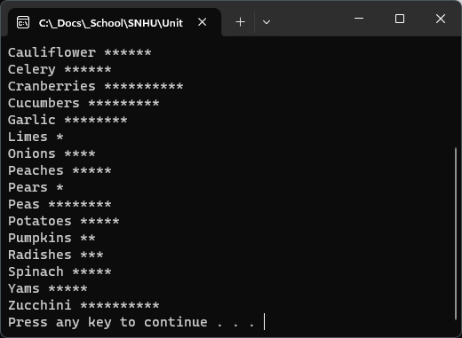

Every time an option is selected (except option 4 or bad choices), the inventory with quantities will be output to a file called “frequency.dat”.

